Creating a WBS and Network Diagram
Name
Institution
Date

Creating a WBS and Network Diagram
Figure 1: WBS for the Upgraded Network Software
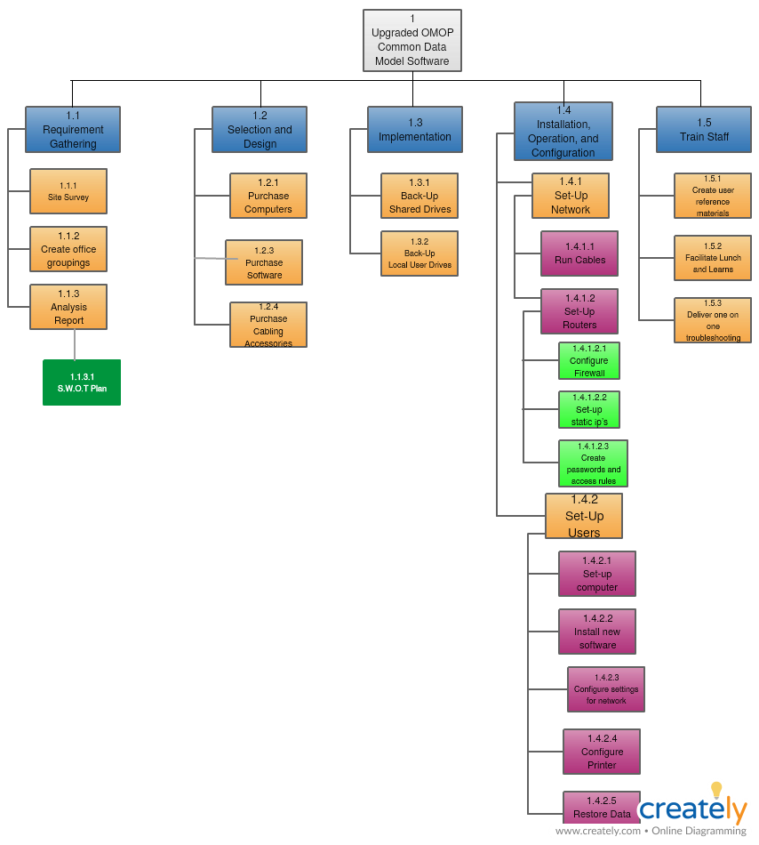
Figure 2: Network Diagram for Upgraded Network Software
